Time series analysis:
A time series is a sequence of data points collected or recorded at regular time intervals.

Key Components of Time Series Data:
- Trend: The long-term increase or decrease in data over time. For example upward or downward trend in stock price.

- Seasonality: Repeating patterns or cycle in data at regular interval of time. (e.g. seasonal sales patterns(Ice cream), temperature variations across seasons over the years)
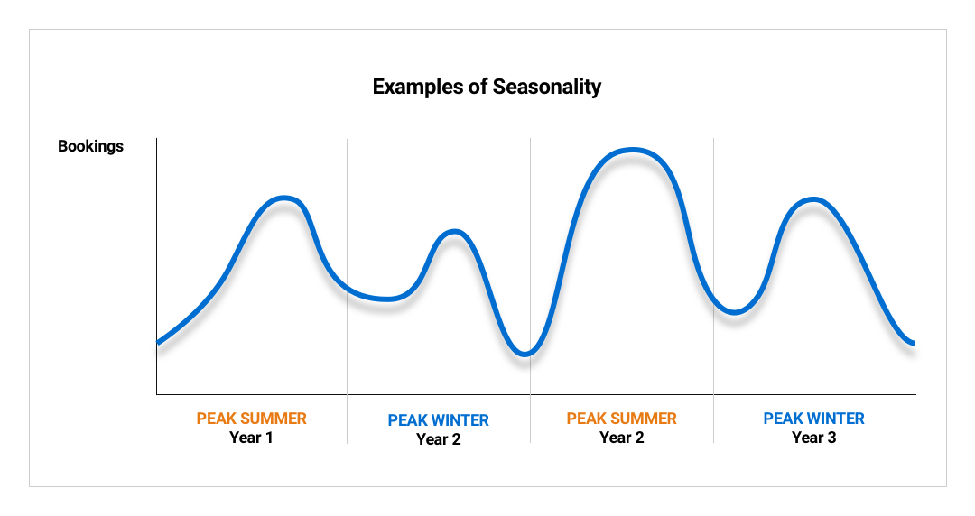

- Cyclic Patterns: Long-term fluctuations that are not fixed in duration but occur over extended periods. Example: Economic growth and recession with no fixed duration between each cycle.
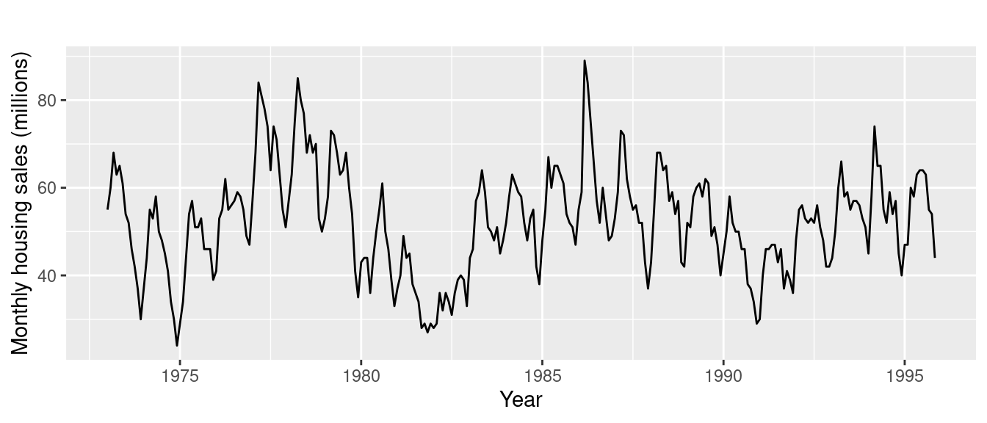
- Noise (Irregularity): Random variations or anomalies that cannot be explained by trend, seasonality, or cycles. Example: random fluctuations in stock prices throughout the day
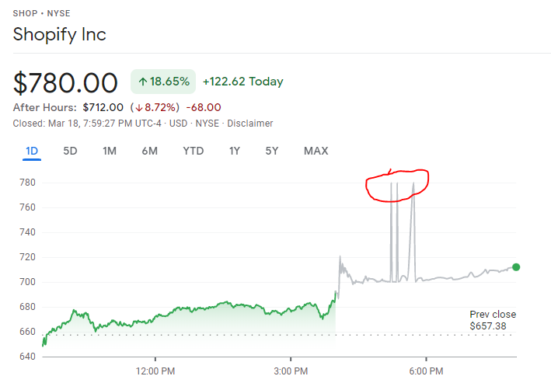

Seasonal Decomposition of Time Series Data:
Seasonal decomposition is a technique used to separate a time series into its constituent components: trend, seasonality, and residual (noise). This is particularly useful for understanding the underlying patterns in the data, which can enhance forecasting accuracy. In Python, the seasonal_decompose function from the statsmodels library can be used to perform this decomposition.
result = seasonal_decompose(sales_data['Sales'], model='additive')
Additive Model: Assumes that the components add together to form the time series.
Multiplicative Model: Assumes that the components multiply together.

# Plotting the results
result.plot()
plt.title('Seasonal Decomposition of Sales Data')
plt.show()

The output will typically consist of four plots:
- Observed: The original time series data.
- Trend: The long-term progression of the series.
- Seasonal: The repeating patterns or cycles in the data.
- Residual: The noise or random variations after removing trend and seasonality.

Plot an individual component of time series:
- Trend : plt.plot(result.trend, label='Trend')
- Seasonality : plt.plot(result.seasonal, label='Seasonality')
- Residue : plt.plot(result.resid, label='Residuals')
What is stationarity in time-series data?
A time series is stationary if its statistical properties, such as mean, variance, and autocorrelation, are constant over time.
Importance of Stationarity:
1. Many time series forecasting models, like ARIMA (AutoRegressive Integrated Moving Average), assume that the underlying data is stationary
2. Stationary data accurately capture relationships within the data.
3. Predictions made on stationary data tend to be more accurate.
Often, time series data is not stationary, but we can transform it to achieve stationarity. Common methods include:
- Differencing: Subtracting the current value of the series from the previous value. This can help remove trends or seasonality.
- Transformation: Applying transformations like logarithms or square roots to stabilize the variance.
- Detrending: Removing the underlying trend component from the series.
Imp Note:
ARIMA requires stationary data but can handle non-stationarity through its differencing component.
Testing for Stationarity:
There are various ways to identify weather the time series data is stationary or not
here are some common techniques:
  - Visual inspection: By looking at a graph of time series data we can see that if the data is stationary or not.

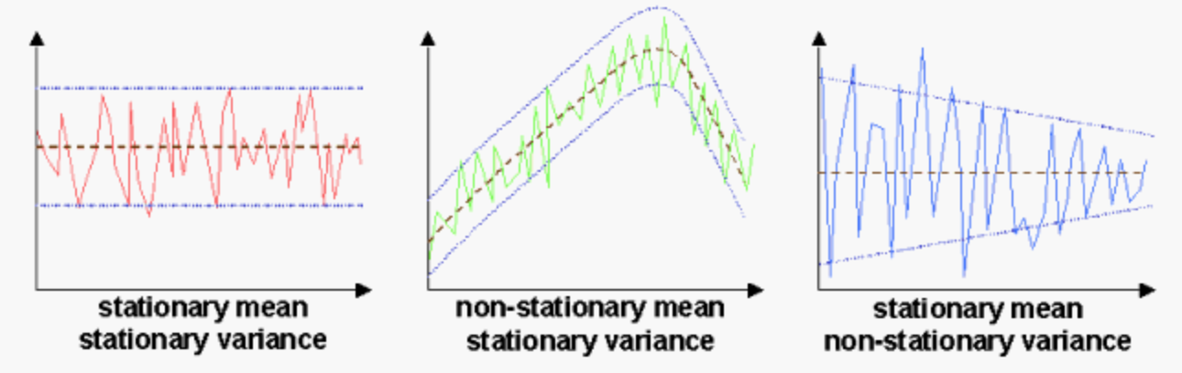

First Plot : both mean and variance are constant so data is stationary
Second plot : mean is not constant, variance is constant, non-stationary data
Third plot : mean is constant, variance is not constant, non-stationary data

  - Statistical tests : There are various statistical test by using we can check if the data is stationary or not as follows
1.Augmented Dickey-Fuller (ADF) test
2.KPSS test:

Augmented Dickey-Fuller (ADF) test:
The Augmented Dickey-Fuller (ADF) test is a widely used statistical method to test for stationarity in a time series
ADF is a type of unit root test
if the time series is having unit root then it is not stationary.
Null hypothesis: The time series has a unit root (non-stationary time series)
Alternative hypothesis: The time series is a stationary
If the test finds sufficient evidence to reject the null hypothesis, you can conclude that the time series is stationary.
If the p-value is less than the significance level (commonly 0.05), you reject the null hypothesis, suggesting the series is stationary.
P < 0.05 ---- reject null hypothesis (Time series is stationary)
p >= 0.05 ---- Failed to reject null hypothesis (Time series is not stationary)
from statsmodels.tsa.stattools import adfuller
# Perform Augmented Dickey-Fuller test
adf_test = adfuller(sales_data['Sales'])
# Display the p-value
print("p-value of ADF test is", adf_test[1])

If the p value is greater than significance level then the time series data is not stationary and may contains trend or seasonality in the data. Now we need to convert the time series to stationarity using following technique
- Differencing:
Differencing technique is used in time series analysis to make a non-stationary time series to stationary. It involves subtracting the previous observation from the current observation.
This help to stabilize the mean and eliminating (or reducing) trend and seasonality.

First Difference: This is the most common form of differencing. It involves subtracting the previous observation from the current observation.
The first difference will remove any trend from the data.
Equation of simple autoregressive model of order 1 is given as
Xt ​= ρ(xt−1​) + et
Where,
Xt :- Current value of time series
Ρ :- Autoregressive coefficient
xt−1 :- Previous value of time series
et :- Error term

Which states that, the current value of time series is equal to some fraction of previous value and a random error.

Here, as the ρ value increases the stationarity decreases.
At ρ = 1 -------- Time series is very non-stationary
If ∣ρ∣<1, the process is stationary
If ∣ρ∣=1, the process is non-stationary
If ∣ρ∣>1, it indicates explosive behaviour, which is generally not desirable in time series modelling.

Now let say time series data is non-stationary
Use first differencing to make the time series stationary

Subtract previous data point from current data point as follows
Xt – (xt−1) ​= ρ(xt−1​) + et – (xt−1)
Take an xt- 1 common from right side
Xt – (xt−1) = xt−1​ (ρ -1) + et
As the time series is non stationary (∣ρ∣=1) then
Xt – (xt−1) = et ------------------ (stationary series)

# Apply first differencing
sales_data_diff = sales_data['Sales'].diff().dropna()

Seasonal Differencing:
After using first difference technique to make the time series stationary and still ADF test indicates non-stationarity then there might be chances of seasonality in the time series and this can be remove using seasonal difference.
For instance, if your data is monthly with a yearly cycle, you would subtract the observation from 12 periods ago.

Forecasting Methods:
Time series forecasting methods are techniques used to predict future values based on previously observed values in time-ordered data sets. These methods are crucial in various fields like finance, economics, weather forecasting, and more.
There are several approaches to time series forecasting, each with its strengths and appropriate use cases:

- Moving Average Methods:
The purpose of moving average is to smooth out short term fluctuations and Help to understand trends. (Smoothing, Trend Identification and forecasting)

- Simple Moving Average:
Uses the average of recent observations to forecast future values.
Simply take the average of the last 'n' observations.
For example : - Moving average of last 3 months:
Sum of last 3 months values (Current month and past 2 months) / 3
# applying a moving average
moving_avg = sales_data['Sales'].rolling(window=12).mean()
# 12 Month moving average

- Weighted Moving Average:
Similar to the simple moving average but gives different weights to different observations. It gives larger weights to the most recent observations and keeps on decreasing as we go in past

- Exponential Smoothing: A more sophisticated version that gives exponentially decreasing weights over time. In exponential smoothing as the value of alpha decreases smoothing of curve increases

- Integrated Models:
  - ARIMA : (Autoregressive integrated moving average)
Combines AR, MA, and differencing to make the data stationary before forecasting.

ARIMA is denoted as ARIMA(p, d, q), where:
- p: Order of the AR term (number of lagged observations).
- d: Order of differencing (number of times the data is differenced to achieve stationarity).
- q: Order of the MA term (number of lagged errors), Smooth out short term fluctuations and help to understand trend

Steps to apply ARIMA:
1. Visualize the time series data to identify trend, seasonality and fluctuations
2. Check the stationarity using ADF, If non-stationary, apply differencing (d>0).
3. Determine Parameters (p, d, q):
Use tools like Autocorrelation Function (ACF) and Partial Autocorrelation Function (PACF):
ACF: Helps determine q (MA terms).
PACF: Helps determine p (AR terms).

Note : Use auto_arima (Python) for automated parameter selection.

4. Fit model
5. Validate model
6. Forecast

from statsmodels.tsa.arima.model import ARIMA
# fit an ARIMA model (example: ARIMA (1, 1, 1))
model_arima = ARIMA (data ['Sales'], order= (1, 1, 1))
results_arima = model_arima.fit ()

# Summary of the ARIMA model
Print (results_arima.summary())

# Forecasting future values
forecast_arima = results_arima.forecast(steps=5)
print("ARIMA Forecast:", forecast_arima)
  - SARIMA (Seasonal AutoRegressive Integrated Moving Average) :
If the time series contains seasonality then use SARIMA model to convert the time series to stationary and do forecast.
SARIMA is extension of ARIMA model which is essentially ARIMA with a seasonal twist.
SARIMA Parameters: (p, d, q) x (P, D, Q, s)
It includes ARIMA's parameters plus four more for seasonality:
- P (Seasonal Past): Similar to 'p', but for the seasonal component. It's about looking back at past seasons.
- D (Seasonal Differencing): Similar to’d’, but applied to seasonal cycles. It's like making seasonal patterns more consistent.
- Q (Seasonal Average): Similar to 'q', but for the seasonal component. It uses past seasonal forecast errors.
- s (Seasonal Cycle Length): The length of the seasonal cycle (e.g., 12 for monthly data with yearly patterns).

##Appying ARIMA model:

from statsmodels.tsa.arima.model import ARIMA
from statsmodels.tsa.statespace.sarimax import SARIMAX
from sklearn.metrics import mean_squared_error
import numpy as np

# Splitting the data into train and test sets
train = sales_data['Sales'].iloc[:-10] # All data except the last 10 observations
test = sales_data['Sales'].iloc[-10:] # Last 10 observations for testing

# Applying ARIMA model (choosing a simple (1,1,1) order for demonstration)
arima_model = ARIMA(train, order=(7, 1, 7))
arima_result = arima_model.fit()
arima_forecast = arima_result.forecast(steps=10)

# Evaluating the models
arima_mse = mean_squared_error(test, arima_forecast)

arima_mse
##Applying SARIMA model:

# Applying SARIMA model (considering a simple seasonal order)
sarima_model = SARIMAX(train, order=(7, 1, 7), seasonal_order=(1, 0, 1, 12)) # Yearly seasonality
sarima_result = sarima_model.fit()
sarima_forecast = sarima_result.forecast(steps=10)

# Evaluating the models
sarima_mse = mean_squared_error(test, sarima_forecast)

sarima_mse

